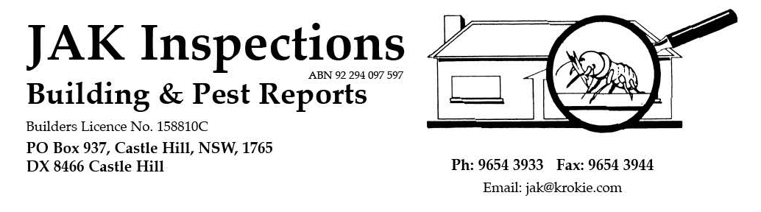

RESIDENTIAL BUILDING REPORT

Complies with Australian Standard AS 4349.1-2007 Property Inspections

– Part 1: Pre-Purchase Inspections - Residential Buildings – Appendix “C”

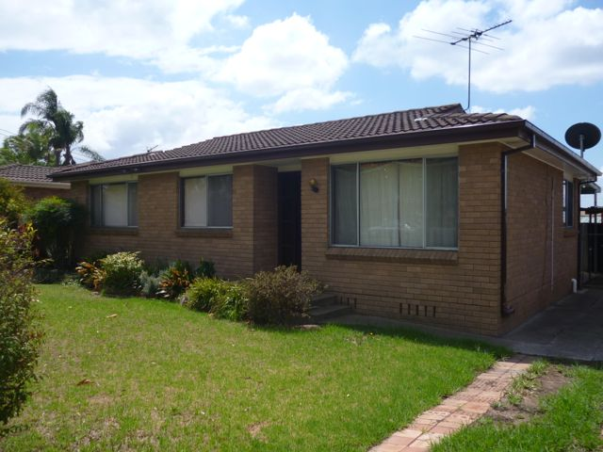

84 Dight Street RICHMOND

Email:

Cooke
Confident Conveyancing
PO Box 832
RICHMOND 2753

4578 2277
4578 2288

Phone:
Fax:
Date of Inspection:

30.1.13

Invoice Number:
130090

Purchaser:

COOKE
Vendor:
RICHARDSON
Structure at:

Your Reference:
3136
Account to:
C/-:
Note: This Report should not be relied upon if the contract for sale becomes binding more than 30 days after the date of initial inspection. A re-inspection after this time is essential.

DETAILS OF THE INSPECTION AGREEMENT

Agreement No. 130090 Date of Agreement: 29.1.13 Time of Agreement: N/A

The Purpose of the Inspection: The purpose of the inspection is to identify the major defects and safety hazards associated with the property at the time of the inspection. The inspection and reporting is limited to Appendix C AS4349.1-2007.

The report does not include an estimate of the cost for rectification of the defects. The overall condition of this building has been compared to similarly constructed and reasonably maintained buildings of approximately the same age.

Are there Specific Requirements / Conditions requested by the Client/Client’s Representative regarding the Inspection and Report: NO

The following list details the Specific Requirements/ Conditions agreed to: N/A

Where there any changes to the Inspection Agreement: NO
• Date the Changed Agreement was accepted: N/A
• Time the Changed Agreement was accepted: N/A

The following list details the changes to the Inspection Agreement requested: N/A

FACTORS THAT INFLUENCED THE INSPECTION / REPORT OUTCOME

Limitations to the Inspection, apart from “Access Issues” noted below, and how these limitations, have affected the Inspection and / or the preparation of the report: N/A

Details of Apparent concealment of possible defects: N/A

Information provided to the inspector that has a bearing on the Inspection and / or Report and from whom and when that information was provided: N/A

Details of other factors influencing the Inspection: N/A

CONCLUSION AND SUMMARY

The purpose of the inspection is to identify the major defects and safety hazards associated with the property at the time of inspection. The Inspection and Reporting is limited to a visual assessment of the Building Members in accord with Appendix C AS4349.1-2007.

The overall condition of this building has been compared to similar constructed buildings of approximately the same age where those buildings have had a maintenance program implemented to ensure that the building members are still fit for purpose.

The incidence of Major Defects in this Residential Building as compared with similar Buildings is considered Typical

The incidence of Minor Defects in this Residential Building as compared with similar Buildings is considered Typical

The overall condition in this Residential Building in the context of its age, type and general expectations of similar properties is: Average

Please Note: This is a general appraisal only and cannot be relied on its own – read the report in its entirety.

This Summary is supplied to allow a quick and superficial overview of the inspection results. This Summary is NOT the Report and cannot be relied upon on its own. This Summary must be read in conjunction with the full report and not in isolation from the report. If there should happen to be any discrepancy between anything in the Report and anything in this Summary, the information in the Report shall override that in this Summary.

NOTE: In accord with AS4349.1-2007, minor defects are not generally reported unless they are arising directly from a Major Defect. The following is stated in the Standard in Section 4.2 REPORT CONTENT - C4.2.8.

“Minor defects are common to most properties and may include minor blemishes, corrosion, cracking, weathering, general deterioration, unevenness, and physical damage to materials and finishes, such as desilvering of mirrors. It is expected that defects of this type would be rectified as part of normal ongoing property maintenance.

It is neither intended nor expected that the report will include details of specific minor defects; however, a poorly maintained residence may have more numerous and extensive minor defects than a reasonably maintained property that is otherwise similar. It follows that it may be necessary for a purchaser to allocate substantial resources to return a poorly maintained property to a reasonable standard of occupancy. For this reason the Standard requires that the report include a general assessment of the general incidence of minor defects in the subject residence compared with otherwise similar properties.”

OTHER INSPECTIONS AND REPORTS REQUIRED

It is Strongly Recommended that the following Inspections and Reports be obtained prior to any decision to purchase the Property and / or before settlement. Obtaining these reports will better equip the purchaser to make an informed decision. These Inspections and Reports fall outside the guidelines for a Standard Property Report as specified in AS4349.1-2007 and are excluded from this Report.

X | Timber Pest Inspection | X | Air conditioning Inspection |  | Hazards Inspection
X | Electrical Inspection |  | Alarm/Intercom/Data Systems |  | Fire/Chimney Inspection
X | Plumbing Inspection |  | Structural (Engineer) |  | Estimating Report
 | Asbestos Inspection |  | Geotechnical Inspection |  | Hydraulics Inspection
 | Mechanical Services |  | Durability of Exposed Surfaces | X | Gas fitting Inspection
 | Drainage Inspection |  | Garage Door Mechanical |  | Strata Inspection
 | Mould Inspection |  | Swimming Pool Inspection |  | Other:
X | Appliances Inspection | X | Council Plan Inspection

Important: Strata Title: Where an item in the inspection findings below is noted as being part of the Common Area, the item is outside the Scope of this Report. It is strongly recommended that an Inspection and Report on these areas be obtained prior to any decision to purchase the Property and / or before settlement. Obtaining these reports will better equip the purchaser to make an informed decision.

Where the property is covered by an Owners Corporation (Strata Title), it is strongly recommended that an Owners Corporation search be conducted to ascertain the financial position, the maintenance / works history carried out by the Owners Corporation and any other relevant information available through the conduct of such an inspection.

IMPORTANT ADVICE

Note: In the case of strata and company title properties, the inspection is limited to the interior and immediate exterior of the particular unit being inspected. The exterior above ground floor level is not inspected. The complete inspection of other common property areas would be the subject of a Special-Purpose Inspection Report, which is adequately specified.

Trees: Where trees are to close to the house, this could affect the performance of the footing as the moisture levels change in the ground. A Geotechnical Inspection can determine the foundation material and advise on the best course of action with regards to the trees.

Septic tanks: Should be inspected by a licensed plumber.

Swimming Pools: Swimming Pools / Spas are not part of the Standard Building Report under AS4349.1-2007 and are not covered by this Report. We strongly recommend a pool expert should be consulted to examine the pool and the pool equipment and plumbing as well as the requirements to meet the standard for pool fencing. Failure to conduct this inspection and put into place the necessary recommendations could result in fines for non compliance under the legislation.

Surface Water Drainage: The retention of water from surface run off could have an effect on the foundation material, which in turn could affect the footings to the house. Best practice is to monitor the flow of surface water and stormwater run off and have the water directed away from the house or to storm water pipes by a licensed plumber / drainer.

TERMINOLOGY

The Definitions of the Terms below apply to the TYPES OF DEFECTS associated with individual items/parts or Inspection areas (fields) of an item:

Damage: The building material or item has deteriorated or is not fit for its designed purpose.
Distortion Warping Twisting: The item has moved out of shape or moved from its position.

Water Penetration Dampness: Moisture has gained access to unplanned and/or unacceptable areas.

Material Deterioration: The item is subject to one or more of the following defects; rusting, rotting, corrosion, decay.

Operational: The item or part does not function as expected.

Installation: The installation of an item is unacceptable, has failed or is absent.

The Definitions below relate to the inspectors opinion of the Overall Condition of the Building:

Major Defect: Is a Defect requiring building works to avoid unsafe conditions, loss of function or further worsening of the defective item.

Minor Defect: Any defect other than what is described as a major defect.

Safety Hazard: Any observed item that may constitute a present or imminent serious safety hazard.

Site: Allotment of land on which a building stands or is to be erected.

Note: Also Refer to “Important Advice” section for explanation/advice concerning some terms and or defects that may be contained in this Report.

HIGH: The frequency and/or magnitude of defects are beyond the inspector’s expectations when compared to similar buildings of approximately the same age that have been reasonably well maintained.

TYPICAL” The frequency and/or magnitude of defects are consistent with the inspector’s expectations when compared to similar buildings of approximately the same age which have been reasonably well maintained.

LOW” The frequency and/or magnitude of defects are lower than the inspector’s expectations when compared to similar buildings of approximately the same age that have been reasonably well maintained.

ABOVE AVERAGE: The overall condition is above that consistent with dwellings of approximately the same age and construction. Most items and areas are well maintained and show a high standard of workmanship when compared with building of similar age and construction.

AVERAGE: The overall condition is consistent with dwellings of approximately the same age and construction. There will be areas or items requiring some repair or maintenance.

BELOW AVERAGE: The Building and its parts show some significant defects and/or very poor non- tradesman like workmanship and/or long term neglect and/or defects requiring major repairs or reconstruction of major building elements.

DETAILS OF THE INSPECTION

Brief Description of Structure(s) Inspected:
The weather condition at the time of the inspection was fine.

Upon inspection of the property we found it to be a domestic single storey brick veneer cottage, timber floor with concrete areas on brick piers with tile roof.

It consisted of 3 bedrooms, lounge, dining, kitchen, laundry, bathroom, WC.

The Areas Inspected:
Only structures, fences within 30m of the main building and within the boundaries of the site were inspected, including The Building Interior, The Building Exterior, The Subfloor, The Roof Space, The Roof Exterior, The Site.

Areas NOT Inspected:
No inspection was made, and no report is submitted, of inaccessible areas. These include, but may not be limited to, concealed frame timbers, eaves, areas concealed by concrete floors, wall linings, soil, landscaping, rubbish, floor coverings, furniture, pictures, appliances, stored items, insulation, hollow blocks/posts or any other obstructions to visual inspection. Furnishings, furniture and stored items were not inspected.

Other Area(s)* to which REASONABLE ACCESS for Inspection was NOT AVAILABLE and the Reason(s) why include: N/A.

Area(s)* in which VISUAL INSPECTION was Obstructed and the Reason(s) why include: Roof space where obstructed by roof insulation material and sarking.

* Please note, since complete inspection of the above areas was not possible, no comment is made on these concealed areas. Further Inspection of these areas is strongly recommended once access has been obtained.

RECOMMENDATIONS TO GAIN ACCESS AND REINSPECT
The Area(s)* and/or Section(s)* to which Access should be gained or fully gained are: N/A

* Further Inspection and Reporting of these areas is Essential once access has been obtained and Prior to a Decision to Purchase to determine if any major defect / safety hazard exists in these areas / sections.

Was the property furnished at the time of inspection?: NO
If the property was furnished at the time of the inspection then you must understand that furnishings and stored goods may be concealing evidence of damage and/or building defects to walls and floors. This evidence may only be revealed when the property is vacated. A further inspection of the vacant property is strongly recommended in this case.

THE INTERIOR OF THE BUILDING

CEILINGS/WALLS:
No Major Defects / Safety Hazards were visible.

Settlement cracking might occur in all residential buildings along ceiling / wall sheet joins, above window and/or door openings, as a result of reactive soils and will patch and paint successfully when next decorated. It should be noted that where highly reactive soils are present, further cracking might occur following adverse weather conditions. The expected consequence of this type of cracking is unknown until further information is obtained.

Patching / painting is required in areas.

Lounge bookshelf is not adequately fixed in place and requires repairs.

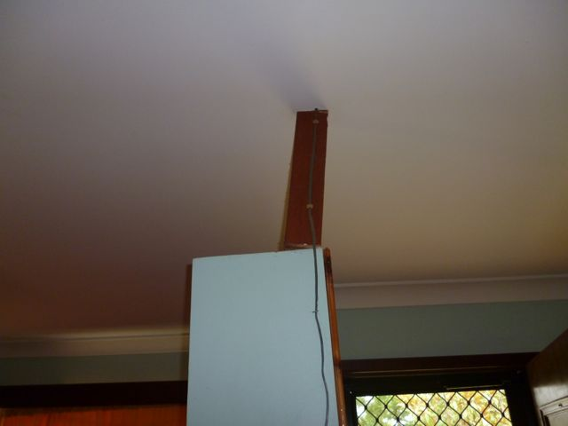

FLOORS:
No Major Defects / Safety Hazards were visible.

Creaking in timber floor / sheet floor construction can occur due to slight shrinkage of timber in service and/or movement in brick piers causing gaps under bearers. In some cases refixing of affected flooring and/or packing under bearers can rectify the situation.

Floor tiles are cracked, show drummy conditions (air pockets under tiles) in areas and requires repairs / and might show deterioration over time. It is recommended that a tiler be engaged to assess the site and provide recommendations.

WINDOWS:
No Major Defects / Safety Hazards were visible.

DOORS:
No Major Defects / Safety Hazards were visible.

Damaged veneer at laundry door and requires repairs. It is recommended a builder be engaged to assess the site and provide recommendations.

KITCHEN:
No Major Defects / Safety Hazards were visible.

Operation of kitchen appliances are not checked in the Property Report and we recommend an electrician and/or relevant service technician be consulted for a more detailed report.

Water damage / damage to bench top / cupboard / shelving and requires repairs.

LAUNDRY:
No Major Defects / Safety Hazards were visible.

Washtub is rusting and requires repairs.

BATHROOM/WC:
No Major Defects / Safety Hazards were visible.

The tests on shower recesses are limited to running water (if water is connected) within the recesses and visually checking for leaks. As showers are only checked for a short period of time, prolonged use may reveal leaks that were not detected at the time of Inspection. The extent of any water damage to concealed timbers cannot be commented on and can only be determined when wall linings are removed. Adequate and proper ongoing maintenance to wet areas will be required in the future. We recommend ongoing monitoring of the condition of the shower recess and of walls surrounding the shower recess.

Washbasin hot water tap is not fully operational and require repairs / maintenance. It is expected that defects of this type would be rectified as part of normal ongoing property maintenance.

SERVICES

TELECOMMUNICATIONS:
All phones, phone lines and outlets, Internet cabling, needs to be inspected and reported on by a telecommunications technician. It is recommended that a licensed telecommunications technician be consulted for a more detailed report.

SMOKE DETECTORS:
AS 3786 – Advises that Smoke Detectors are required for all buildings where people sleep. It is recommended that an electrician be consulted to advise on those installed or to install these detectors.

The inspection is limited to the location of smoke detectors and number installed. Checking the operation of the smoke detector is not a part of the Property Report.

A smoke detector was located in each end of the hall.

ELECTRICAL:
All electrical wiring, meter box and appliances need to be checked by a qualified electrician. The checking of any electrical item is outside the Scope of this Report. It is recommended that a licensed electrician be consulted for a more detailed report.

Operation of air conditioners is not checked in the Property Report and we recommend an electrician and / or relevant service technician be consulted for a more detailed report.

PLUMBING:
All plumbing needs to be inspected and reported on by a qualified plumber. It is recommended that a licensed plumber be consulted for a more detailed report.

Where overflow relief pipes are connected to hot water services, these should be connected to a drainage point to prevent water pooling at base of the building. All hot water services need to be inspected and reported on by a licensed plumber and/or electrician.

Gas is connected. All gas services need to be inspected and reported on by a gas plumber. Operation and adequacy of gas fittings is not checked in the Property Report and we recommend a licensed gas plumber be consulted for a more detailed report.

THE EXTERIOR OF THE BUILDING

WALLS:
External walls are masonry brick.

No Major Defects / Safety Hazards were visible.

Cracking is present to sections of external masonry walls. For details and recommendations see “Cracking Of Building Members” at end section of this report.

Settlement cracking might occur in brickwork in all residential buildings as a result of footings design and reactive soils. It should be noted that where highly reactive soils are present, further cracking might occur following adverse weather conditions. The expected consequence of this type of cracking is unknown until further information is obtained.

High external soil, concrete, paver levels at base of cottage is conducive to moisture levels rising within the wall cavity and may cause deterioration to the building elements and is also conducive to undetected termite entry. External soil levels should be lowered where possible. It is recommended that a builder be engaged to assess the site and provide recommendations.

Rear porch steel handrail is loose and requires repairs. It is recommended a builder be engaged to assess the site and provide further recommendations.

WINDOWS:
No Major Defects / Safety Hazards were visible.

PAINT:
No Major Defects / Safety Hazards were visible.

External protective paintwork provides protection from deterioration to external services from weathering. Where external paintwork is showing deterioration and/or not completed in areas, painting is required. It is expected that defects of this type would be rectified as part of normal ongoing property maintenance.

ATTACHMENTS:
An attached metal awning is constructed at rear elevation.

No Major Defects / Safety Hazards were visible.

Timber infill cladding at rear elevation eaves is not finished in a tradesman like manner. It is recommended a builder be engaged to assess the site and provide further recommendations.

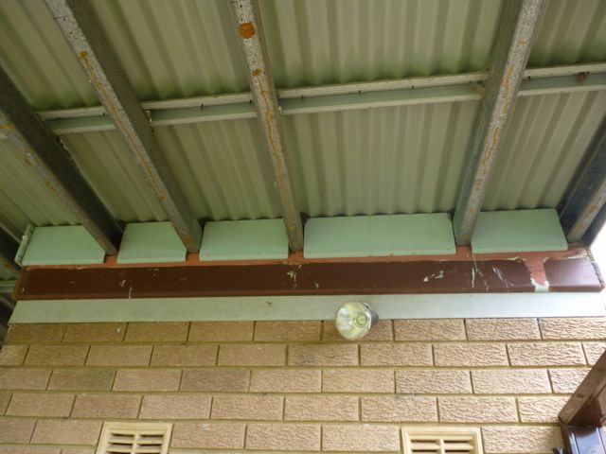

THE SUBFLOOR

No Major Defects / Safety Hazards were visible.

The subfloor area is a timber floor construction with engaged / isolated piers.

Formwork / loose timbers / stored items in contact with soil in the subfloor area are conducive to termite attack and removal of any such items is required.

TERMITE SHIELDS (Ant Caps):
Should be in good order and condition so termite mud tubes are exposed and visible. This helps to stop termites gaining undetected entry. Missing, damaged or poor termite shields/barriers increase the risk of infestation.

It is considered that the termite shield/barriers are generally inadequate as rusting in sections to the extent that the termite shields might be compromised. It is recommended that a builder be engaged to assess the site and provide recommendations.

SUBFLOOR DRAINAGE:
Adequate drainage is important in minimising infestations by timber pests and preventing damp problems.

It is considered that the drainage to the subfloor area is adequate, however possible water channelling / pooling in areas due to slope of land. It is recommended that a plumber be engaged to assess the site and provide recommendations.

SUBFLOOR VENTILATION:
Ventilation is important in minimising infestations by timber pests and preventing damp problems.

It is considered that the subfloor ventilation in this property is adequate.

THE ROOF SPACE

No Major Defects / Safety Hazards were visible.

The roof area is a conventional cut roof construction.

Roof insulation material, sarking is present and prevents a full visual inspection of the roof space timbers.

Sarking has several penetration points / tears / damage to the extent that water penetration might occur within the building and requires sealing / repairs. It is recommended that a builder be engaged to assess the site and provide recommendations.

THE ROOF EXTERIOR

The foregoing is an opinion of the general quality and condition of the roofing material. The Inspector cannot and does not offer an opinion or warranty as to whether the roof leaks or may be subject to future leakage. The only way to determine whether a roof is absolutely watertight is to make observations during prolonged rainfall. If any sections of the roof were inaccessible due to the method of construction or other factors, further investigations should be carried out prior to purchase.

Physical access to roof covering is not possible due to OH&S regulations and a visual inspection from ladder height at random areas was carried out.

No Major Defects / Safety Hazards were visible.

The roof covering is cement tiles.

Minor cracking and mortar loss might occur in roof capping / verge tiles due to general movement and weathering. Periodic maintenance to roof capping / verge tiles is recommended as water ingress might occur during adverse weather.

Terra cotta and concrete roof tiles are easily chipped / cracked at edges during placement of tiles and as a result of age to the extent that the tiles might require replacement should water penetration occur within the building. The likelihood of water penetration into the building is unknown until further information is obtained. It is recommended that a roof tiler be engaged to assess the site and provide recommendations.

Guttering / downpipes should be inspected by a plumber to detail the requirements to ensure that guttering and downpipes are functional and adequate for the situation.

Downpipes should be connected to storm water systems to carry away rain water or discharge on grounds adequately so as not to undermine structures.

Mortar loss / cracking / damage have occurred to sections of the ridge capping to the extent that water penetration might occur within the building. Repointing / repairs to ridge capping is required. It is recommended that a roof tiler be engaged to assess the site and provide recommendations.

Roof flashing has split in areas and requires repairs. It is recommended that a builder be engaged to assess the site and provide recommendations.

THE SITE

OUTBUILDINGS:
Rear yard shedding is not constricted in a tradesman like manner and should be regarded as temporary shedding.

VEHICLE ACCOMMODATION:
Vehicle accommodation is free standing metal carport.

Carport is not constructed in a tradesman like manner. It is recommended that a builder be engaged to assess the site and provide recommendations.

PATHS/DRIVEWAY:
No Major Defects / Safety Hazards were visible.

Subsidence / cracking has occurred in paths / driveway to the extent that the paths / driveway might become a trip hazard. It is recommended that a concreter be engaged to assess the site and provide recommendations.

Subsidence has occurred in pavers to the extent that the pavers might become a trip hazard. It is recommended that a landscaper be engaged to assess the site and provide recommendations.

FENCING:
Metal colorbond fencing is constructed.

No Major Defects / Safety Hazards were visible.

Fencing is rusting / showing damage in sections to the extent that the fence might require repairs.

SURFACE WATER DRAINAGE:
The general adequacy of site drainage is not included in the Property Report. Comments on surface water drainage are limited, as where there has been either little or no rainfall for a period of time, surface water drainage may appear adequate but then during periods of heavy rain, may be found to be inadequate. Any comments made in this section are relevant only in light of the conditions present at the time of inspection. It is recommended that a Smoke Test be obtained to determine any illegal connections and blocked or broken drains.

CRACKING OF BUILDING MEMBERS

Is there cracking to the Building Members?: YES

Regardless of the appearance of the cracks a Pre Purchase Building Inspector carrying out a Pre Purchase Inspection within the scope of a visual inspection is unable to determine the expected consequences of the cracks.

Obtaining information regarding;

(a) The nature of the foundation material on which the building is resting,
(b) The design of the footings,
(c) The site landscape,
(d) The history of the cracks and,
(e) Carrying out an invasive inspection

All fall outside the scope of this Pre Purchase Inspection. However, the information obtained from the five items above are valuable, in determining the expected consequences of the cracking and any remedial work needed.

Cracks that are small in width and length on the day of the Inspection may have the potential to develop over time into Structural Problems for the Home Owner resulting in major expensive rectification work being carried out.

AREAS INSPECTED | LOCATION | Description of the Cracking Defect at time of Inspection
Concrete Slabs | N/A
Suspended Concrete Slabs | N/A
Masonry Walls | External brickwork | Appearance Cracking Defect noted in brick walls
Piers | N/A
Retaining Walls | N/A
Other Areas | N/A

If cracks have been identified in the Table above, then a Structural Engineer is required to determine the significance of the cracking prior to a decision to purchase or settlement.

DESCRIPTION TERMINOLOGY

Appearance Defect- Where in the inspector’s opinion the appearance of the building item has deteriorated at the time of the inspection and the expected consequence of this cracking is unknown until further information is obtained.

Serviceability Defect- Where in the inspector’s opinion the performance of the building item is flawed at the time of the inspection and the expected consequence of this cracking is unknown until further information is obtained.

Structural Defect - Where in the inspector’s opinion the structural soundness of the building item has diminished at the time of the inspection and the expected consequence of this cracking is unknown until further information is obtained.

IMPORTANT: All Recommendations made in the above Inspection Findings or elsewhere in this Report should be carried out / or considered in your decision process, prior to purchase or settlement.

IMPORTANT INFORMATION REGARDING THE SCOPE AND LIMITATIONS OF THE INSPECTION AND THIS REPORT

Any person who relies upon the contents of this report does so acknowledging that the following clauses, which define the Scope and Limitations of the Inspection, form an integral part of the Report.

1. This Report is NOT an all encompassing report dealing with the building from every aspect. It is a reasonable attempt to identify any obvious or significant defects apparent at the time of the inspection. Whether or not a defect is considered significant or not, depends, to a large extent, upon the age and type of the building inspected. This Report is not a Certificate of Compliance with the requirements of any Act, Regulation, Ordinance or By-law, or, as a warranty or an insurance policy against problems developing with the building in the future. It is not a structural report. Should you require any advice of a structural nature you should contact a structural engineer.

2. THIS IS A VISUAL INSPECTION ONLY limited to those areas and sections of the property fully accessible and visible to the Inspector on the date of the inspection. The Inspection DID NOT include breaking apart, dismantling, removing or moving objects including, but not limited to, foliage, mouldings, roof insulation/sisalation, floor or wall coverings, sidings, ceilings, floors, furnishings, appliances or personal possessions. The Inspector CANNOT see inside walls, between floors, inside skillion roofing, behind stored goods in cupboards and other areas that are concealed or obstructed. The Inspector DID NOT dig, gouge, force or perform any other invasive procedures. Visible timbers CANNOT be destructively probed or hit without the written permission of the property owner. An INVASIVE INSPECTION will not be performed unless a separate contract is entered into. In an occupied property it must be understood that furnishings or household items may be concealing evidence of defects which may only be revealed when the items are removed.

3. REASONABLE ACCESS. Only areas to which reasonable access is available were inspected. The Australian Standard 4349.1 defines reasonable access as “areas where safe, unobstructed access is provided and the minimum clearances specified below are available, or where these clearances are not available, areas within the inspector’s unobstructed line of sight and within arm’s length. Reasonable access does not include removing screws and bolts to access covers” Reasonable access does not include the use of destructive or invasive inspection methods nor does it include cutting or making access traps or moving heavy furniture, floor coverings or stored goods.

Roof void: Access hole 450 x 400mm, Crawl space 600 x 600mm, Accessible from 2.1m step ladder or where possible a 3.6m ladder placed against a wall.

Roof Exterior: Accessible from a 3.6m ladder. No detailed inspection is inferred to external areas over 3.6 meters above the natural ground level.

4. This Property Report does not and cannot make comment upon: defects that may have been concealed; the assessment or detection of defects (including rising damp and leaks) which may be subject to the prevailing weather conditions; whether or not services have been used for some time prior to the inspection and whether this will affect the detection of leaks or other defects (eg. In case of shower enclosures the absence of any dampness at the time of the inspection does not mecessarily mean that the enclosure will not leak); the presence or absence of timber pests; gas fittings; common property areas; environmental concerns; the proximity to flight paths, railways, or busy traffic; noise levels; health and safety issues; heritage concerns; fire protection; site drainage (apart from surface water drainage); swimming pools and spas (non-structural); detection and identification of illegal building work; detection and identification of illegal plumbing work; durability of exposed finishes; neighbourhood problems; document analysis; electrical installations; any matters that are solely regulated by statute; any area(s) or item(s) that could not be inspected by the Consultant.

Accordingly this Report is NOT A GUARANTEE that a building related defect and / or damage does not exist in any inaccessible or partly inaccessible areas or sections of the property. (NB: Such matters may upon request be covered under the terms of a Special-purpose Property Report).

5. CONSUMER COMPLAINTS PROCEDURE. In the event of any dispute or claim arising out of, or relating to the Inspection or the Report, You must notify Us as soon as possible of the dispute or claim by email, fax or mail. You must allow Us (which includes persons nominated by Us) to visit the property (which must occur within twenty eight (28) days of Your notification to Us) and give Us full access in order that we may fully investigate the complaint. You wiull be provided with a written response to your dispute or claim within twenty eight (28) days of the date of the inspection.

If You are not satisfied with our response You must withintwenty one (21) days of Your receipt of Our written response refer the matter to a Mediator nominated by Us from the Institute of Arbitrators and Mediators of Australia. The cost of the Mediator will be borne equally by both parties or as agreed as part of the mediated settlement.

Should the dispute or claim not be resolved by mediation then the dispute or claim will proceed to arbitration. The Institue of Arbitrators and Mediators of Australia will appoint an Arbitrator who will hear and resolve the dispute. The arbitration, subject to any directions of the Arbitrator, will proceed in the following manner:

(a) The parties must submit all written submissions and evidence to the Arbitrator within twenty one (21) days of the appointment of the Arbitrator; and

(b) The arbitration will be held within twenty one (21) days of the Arbitrator receiving the written submissions.

The Arbitrator will make a decision determining the dispute or claim within twenty one (21) days of the final day of the arbitration. The Arbitrator may, as part of his determination, determine what costs, if any, each of the parties are to pay and the time by which the parties must be paid any settlement costs.

The decision of the Arbitrator is final and binding on both parties. Should the Arbitrator order either party to pay any settlement amount or costs to the other party but not spcify a time for payment then such payment shall be made within twenty one (21) days of the order.

In the event You do not comply with the above Complaints Procedure and commence litigation against Us then you agree to fully indemnify Us against any awards, costs, legal fees and expenses incurred by Us in having your litigation set aside or adjourned to permit the foregoing Complaints Procedure to complete.

6. ASBESTOS DISCLAIMER: “No inspection for asbestos was carried out at the property and no report on the presence or absence of asbestos is provided. If during the course of the Inspection asbestos or materials containing asbestos happened to be noticed then this may be noted in the general remarks section of the report. If asbestos is noted as present within the property then you should seek advice from a qualified asbestos removal expert as to the amount and importance of the asbestos present and the cost of removal. Buildings built prior to 1982 may have wall and / or ceiling sheeting and other products including roof sheeting that contains Asbestos. Even buildings built after this date up until the early 90’s may contain some Asbestos. Sheeting should be fully sealed. If concerned or if the building was built prior to 1990 or if Asbestos is noted as present within the property then you should seek advice from a qualified asbestos removal expert as to the amount and importance of the asbestos present and the cost of sealing or removal. Drilling, cutting or removing sheeting products containing Asbestos is a high risk to people’s health. You should seek advice from a qualified asbestos removal expert.”

7. MOULD (MILDEW AND NON-WOOD DECAY FUNGI) DISCLAIMER: Mildew and non wood decay fungi is commonly known as Mould. However, Mould and their spores may cause health problems or allergic reactions such as asthma and dermatitis in some people. No inspection for Mould was carried out at the property and no report on the presence or absence of Mould is provided. If in the course of the Inspection, Mould happened to be noticed it may be noted in the general remarks section of the report. If Mould is noted as present within the property or if you notice Mould and your are concerned as to the possible health risk resulting from its presence then you should seek advice from your local Council, State or Commonwealth Government Health Department or a qualified expert such as an Industry Hygienist.

8. MAGNESITE FLOORING DISCLAIMER: No inspection for magnesite flooring was carried out at the property and no report on the presence or absence of Magnesite Flooring is provided. You should ask the owner whether Magnesite Flooring is present and/or seek advice from a Structural Engineer.

9. ESTIMATING DISCLAIMER: Any estimates provided in this report are merely opinions of possible costs that could be encountered, based on the knowledge and experience of the inspector, and are not estimates in the sense of being a calculation of the likely costs to be incurred. The estimates are NOT a guarantee or quotation for work to be carried out. The actual cost is ultimately dependent upon the materials used, standard of work carried out, and what a contractor is prepared to do the work for. It is recommended in ALL instances that multiple independent quotes are sourced prior to any work being carried out. The inspector accepts no liability for any estimates provided throughout this report.

IMPORTANT DISCLAIMER

DISCLAIMER OF LIABILITY:- No Liability shall be accepted on account of failure of the within Report to notify any problems in any area(s) or section(s) of the subject property physically inaccessible for inspection or to which access for inspection is denied by or to the Consultant (including but not limited to any area(s) or section(s) so specified by the Report).

DISCLAIMER OF LIABILITY TO THIRD PARTIES:- Compensation will only be payable for losses arising in contract or tort sustained by the Client named on the front of this Report. Any third party acting or relying on this Report, in whole or in part does so at their own risk. However, if ordered by a Real Estate Agent or a Vendor for the purpose of auctioning a property then the Inspection Report may be ordered up to seven (7) days prior to the auction, copies may be given out prior to the auction and the Report will have a life of fourteen (14) days during which time it may be transferred to the purchaser. Providing the purchaser agrees to the terms of this agreement then they may rely on the report subject to the terms of this agreement and the Report itself.

CONTACT THE INSPECTOR

Please feel free to contact the inspector who carried out this inspection. Often it is very difficult to fully explain situations, problems, access difficulties, building faults or their importance in a manner that is readily understandable by the reader. Should you have any difficulty in understanding anything contained within this report then you should immediately contact the inspector and have the matter explained to you. If you have any questions at all or require any clarification then contact the inspector prior to acting on this report.

The Inspection & Report was carried out by:
Insurance Accreditation No:
John Krok A. Dip App Sc (Building)

Builders Licence:
0432
Date of Inspection:
30th January 2013

SIGNED FOR AND ON BEHALF OF:
J.A.K. INSPECTIONS

John Krok

158810C

